**Lab 01: Classes Subclasses**

**Adding Class Tab:**

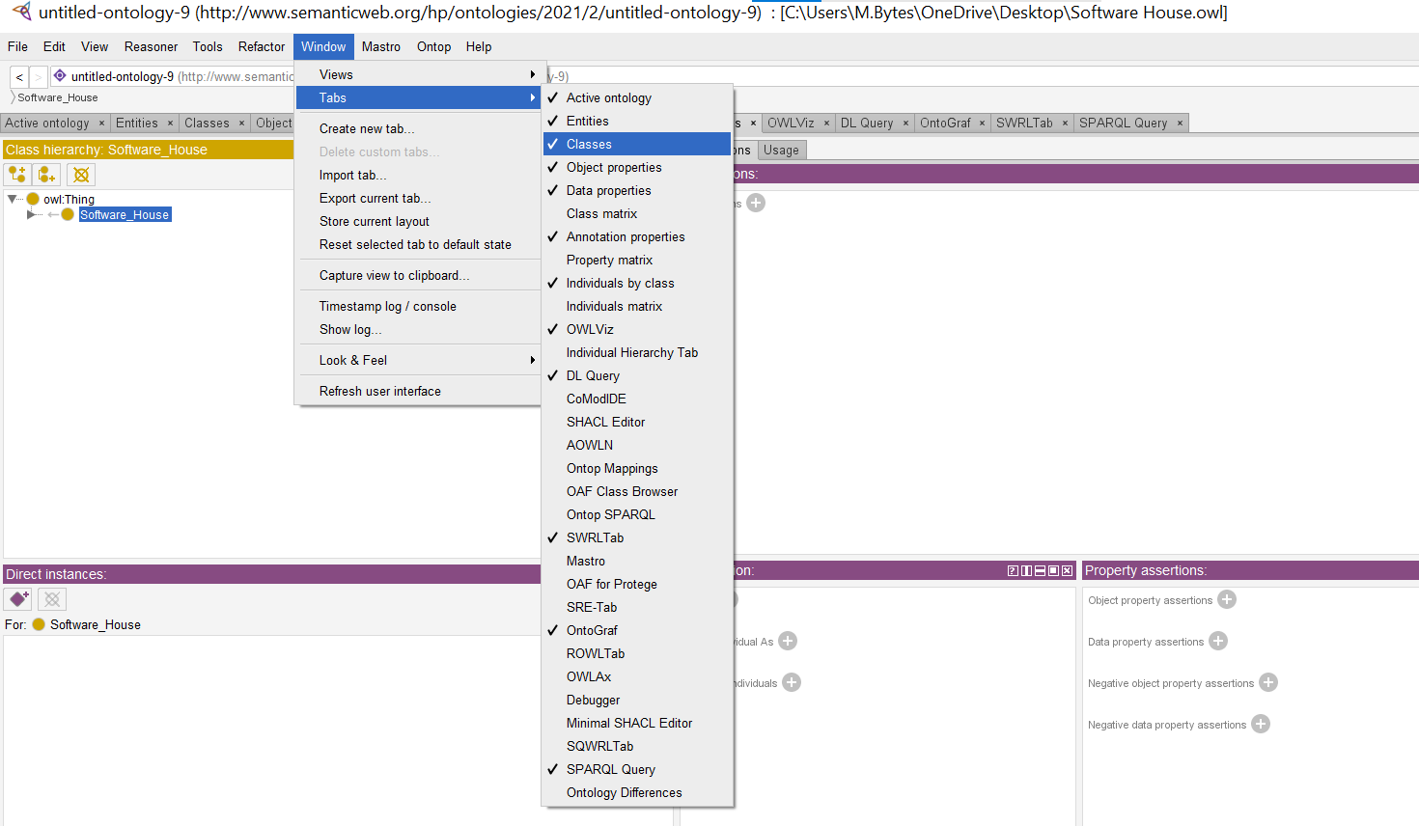

**Adding Class Hierarchy view:**

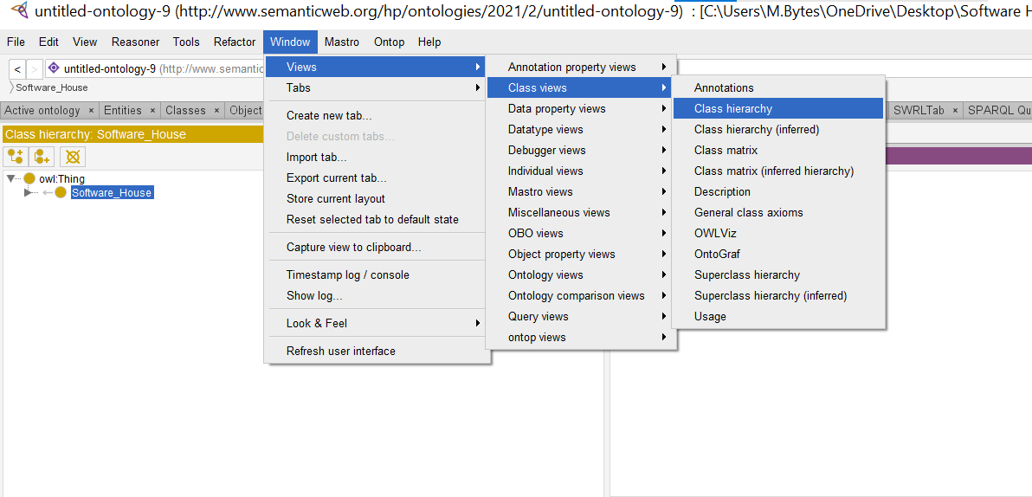

**Creating a New Class:**

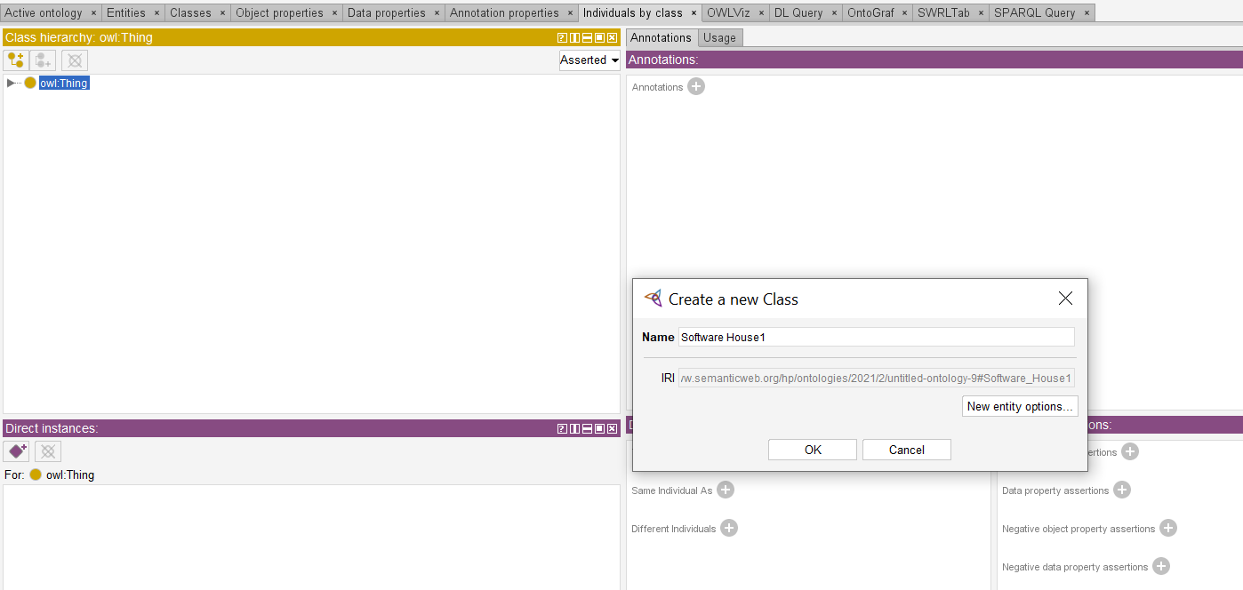

**Creating a Subclass:**

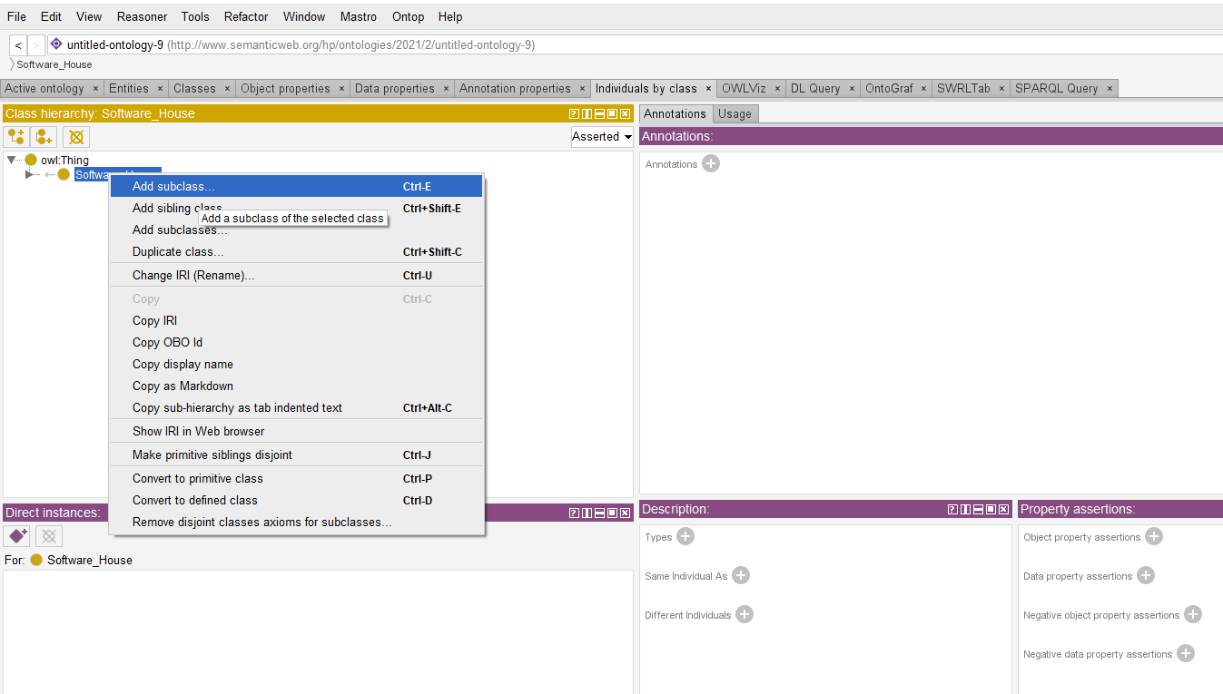

**Classes and Subclasses:**

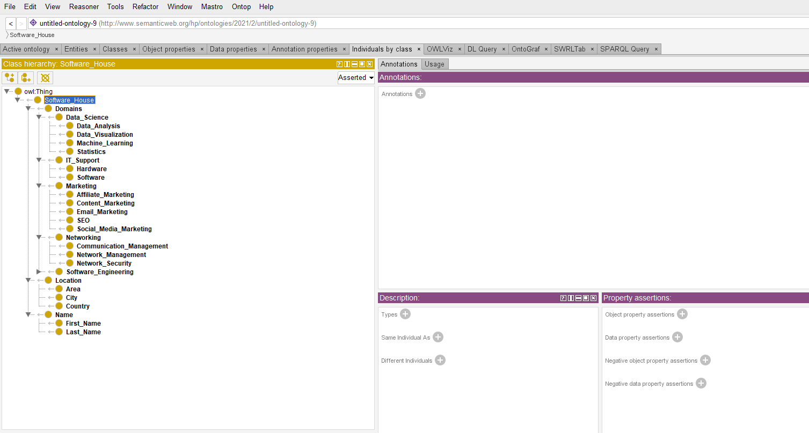

**Lab 02: Data Property**

**Adding Data Property Tab:**

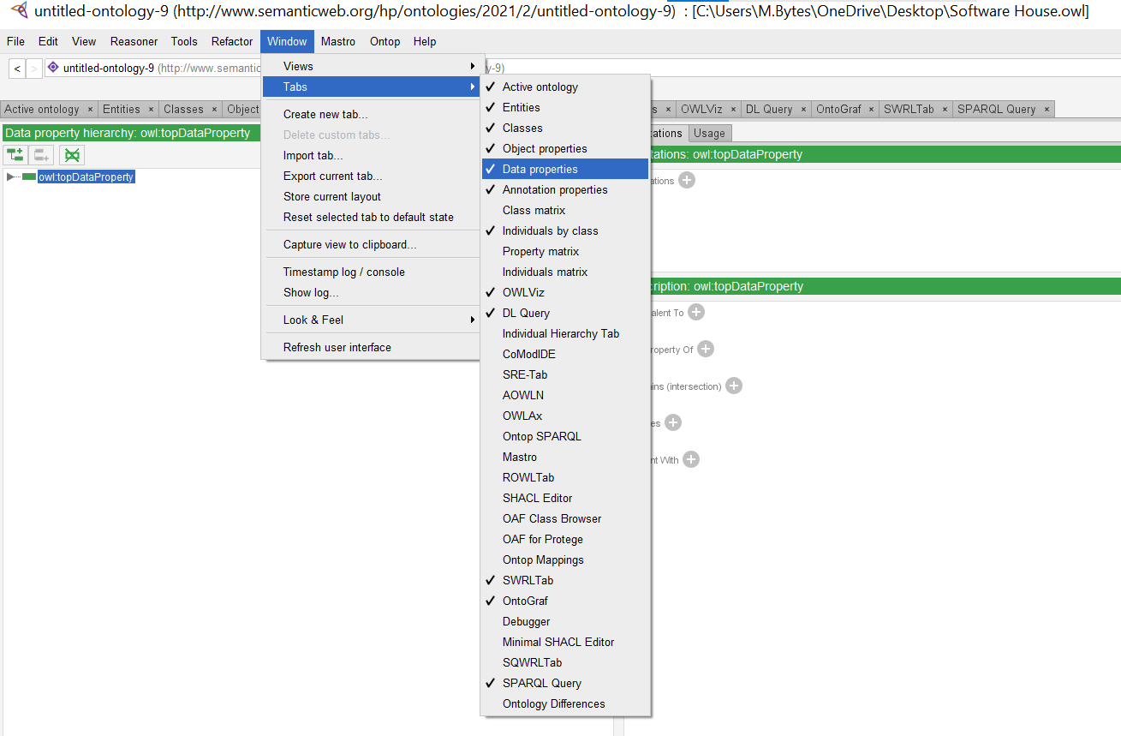

**Adding Data Property Hierarchy View:**

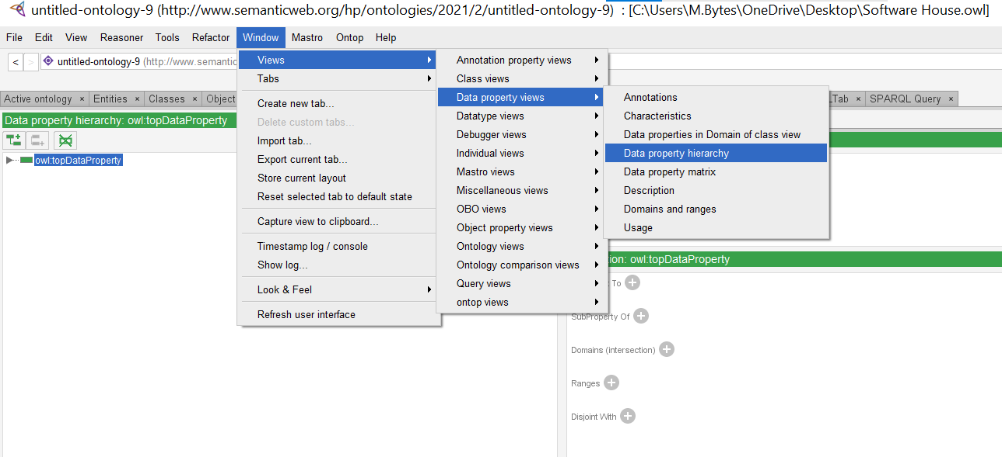

**Creating Data Property:**

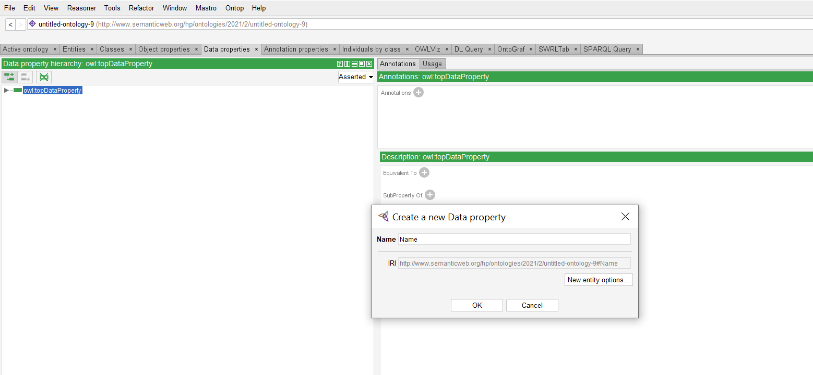

**Domain Range to Data Property:**

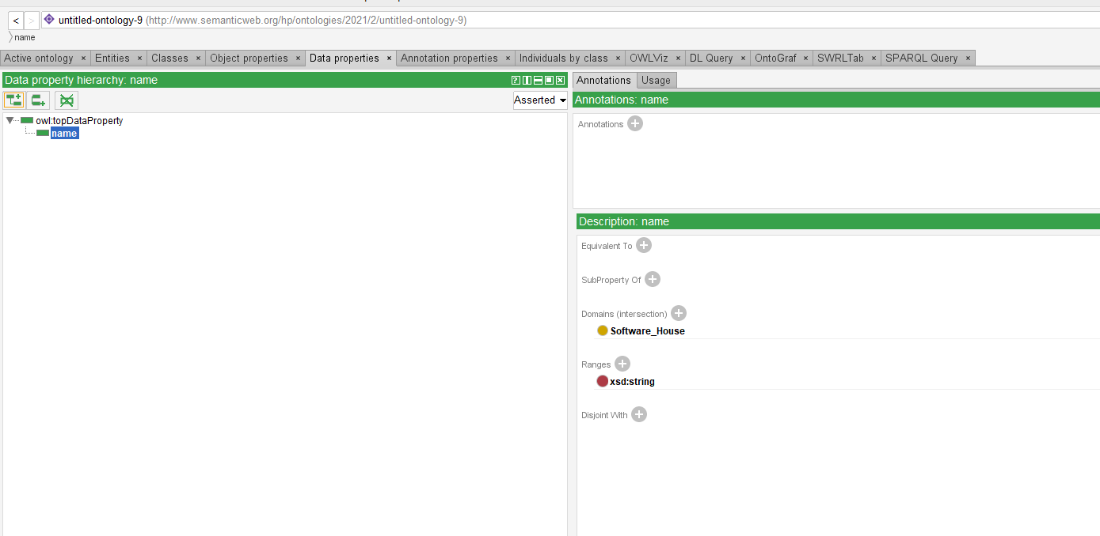

**Lab 03: Object Property**

**Adding Object Property Tab:**

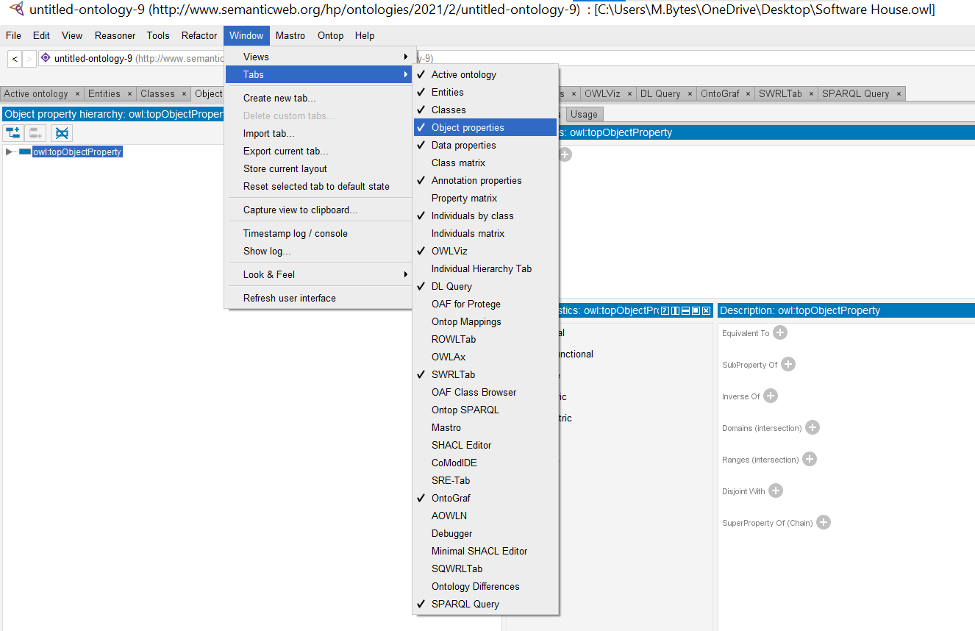

**Adding Object Property View:**

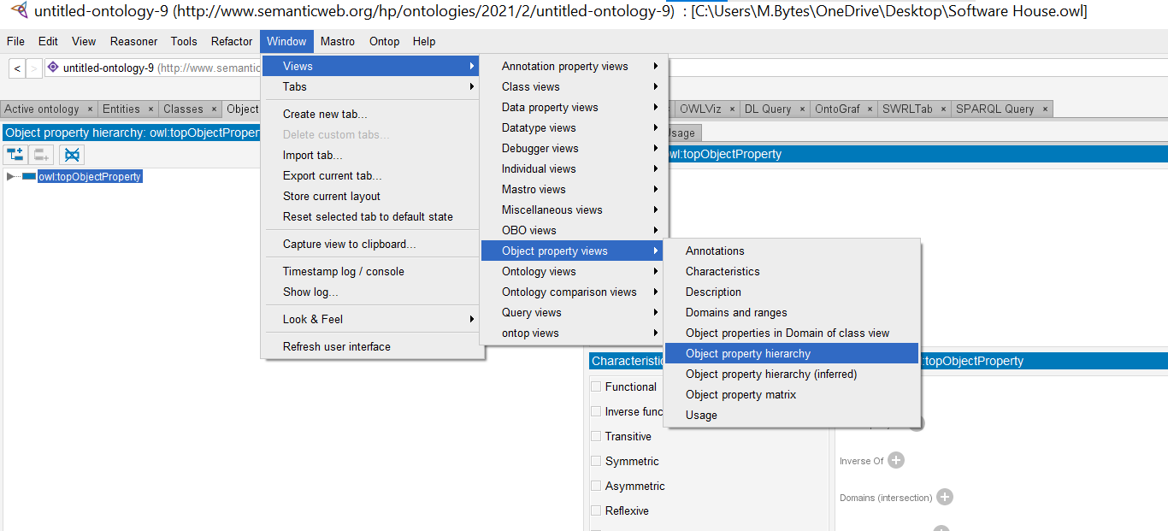

**Creating Object Property:**

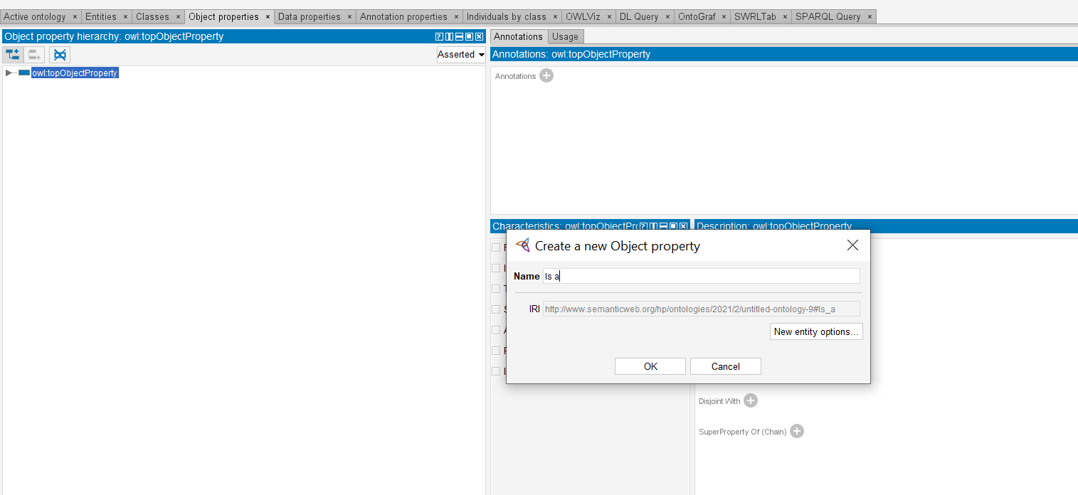

**Domain Range of Object Property:**

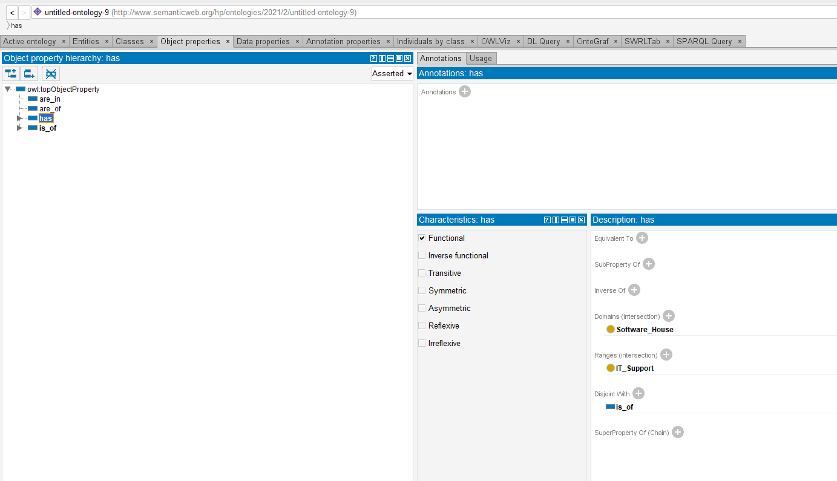

**Lab 04: Object Sub Property**

**Creating Object Sub Property:**

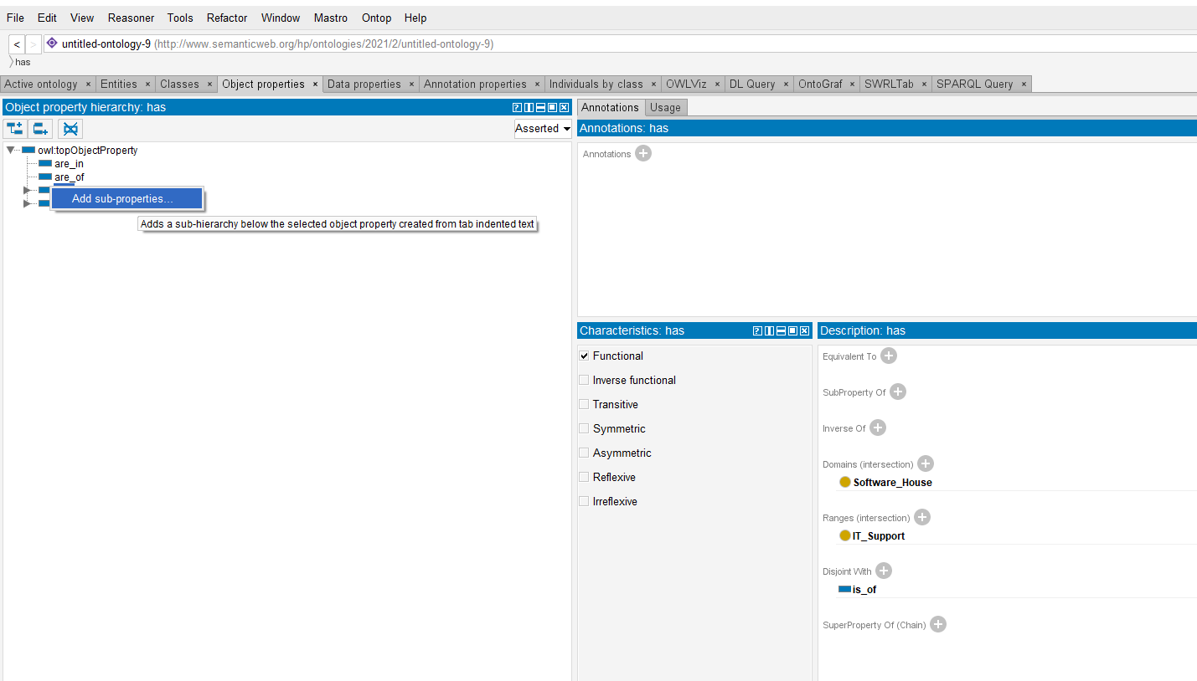

**Object Properties and Sub Properties:**

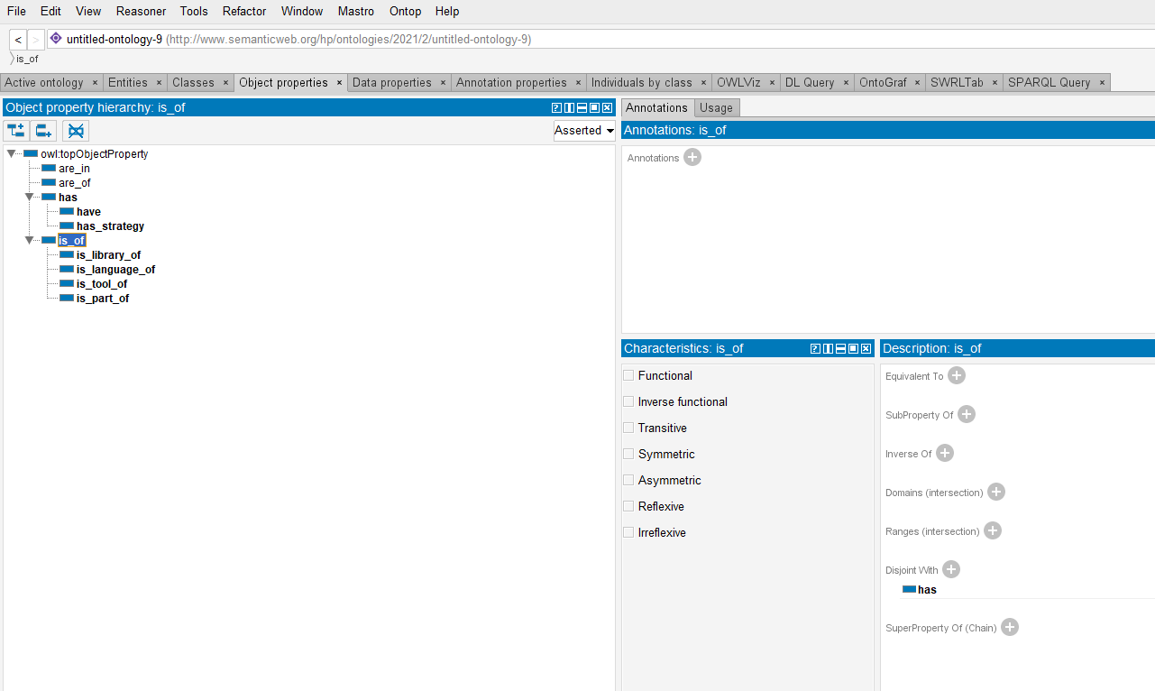

**Lab 05: Properties (inverse, transitive, functional, symmetric etc.)**

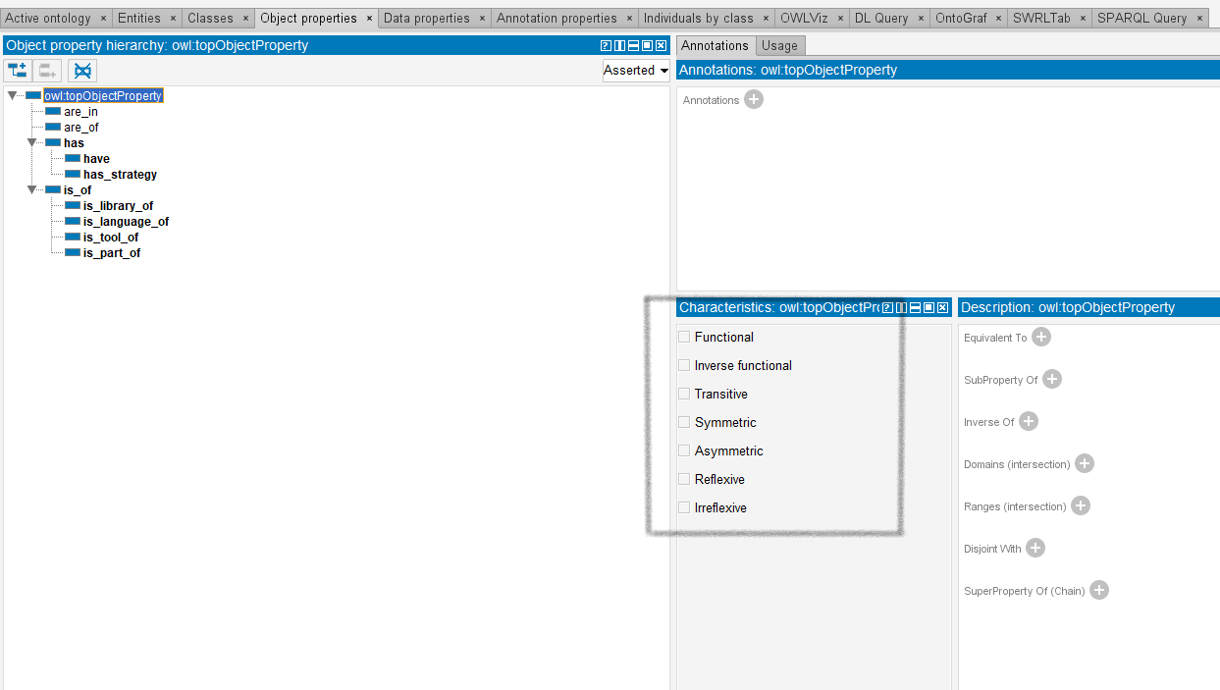

**Lab 06: Equivalent to**

**Equivalent Classes:**

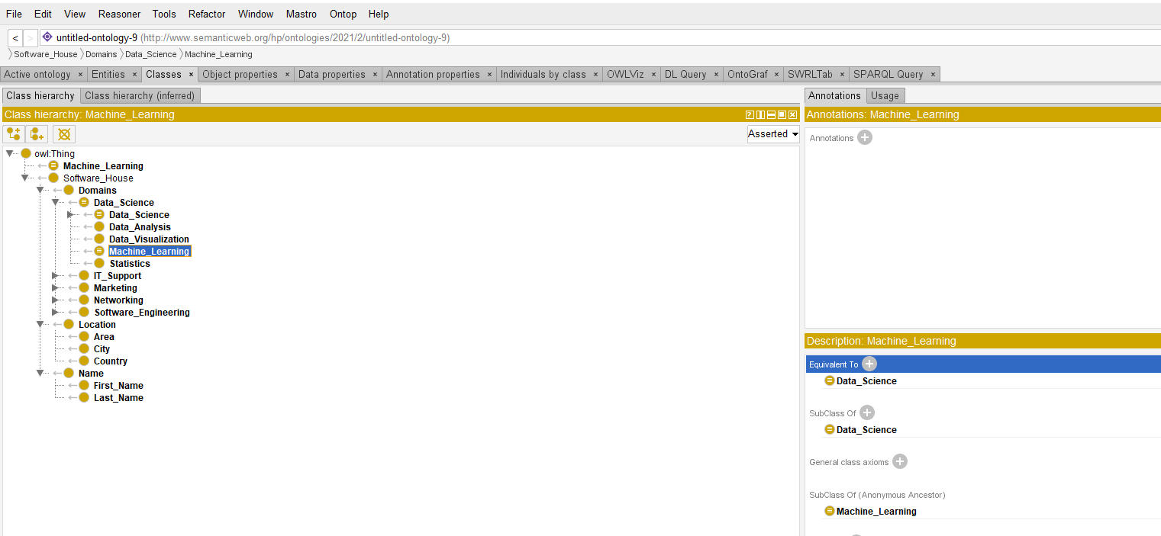

**Equivalent Object Property:**

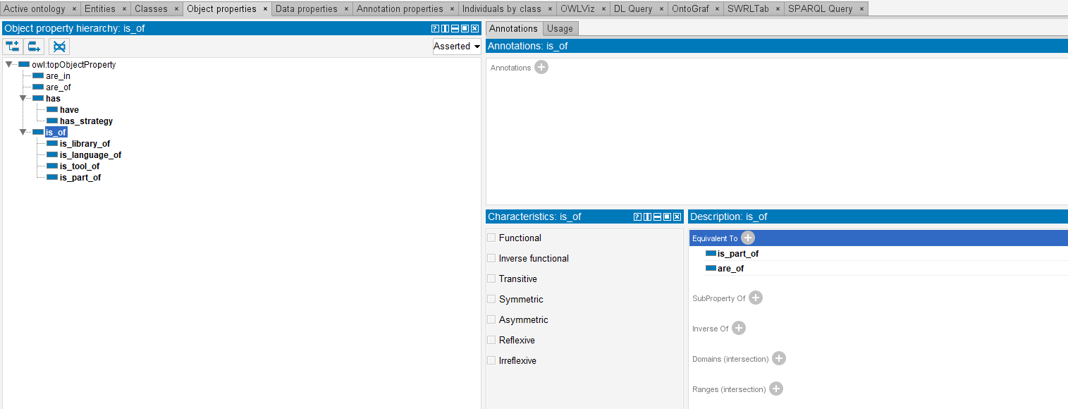

**Equivalent Data Property:**

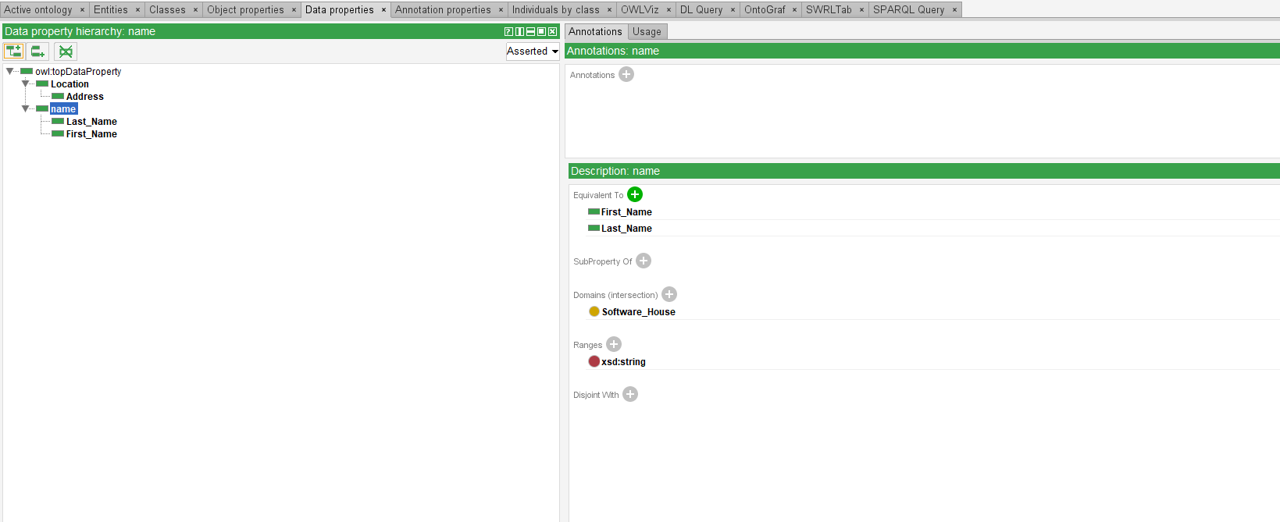

**Lab 07: Disjoint**

**Disjoint Classes:**

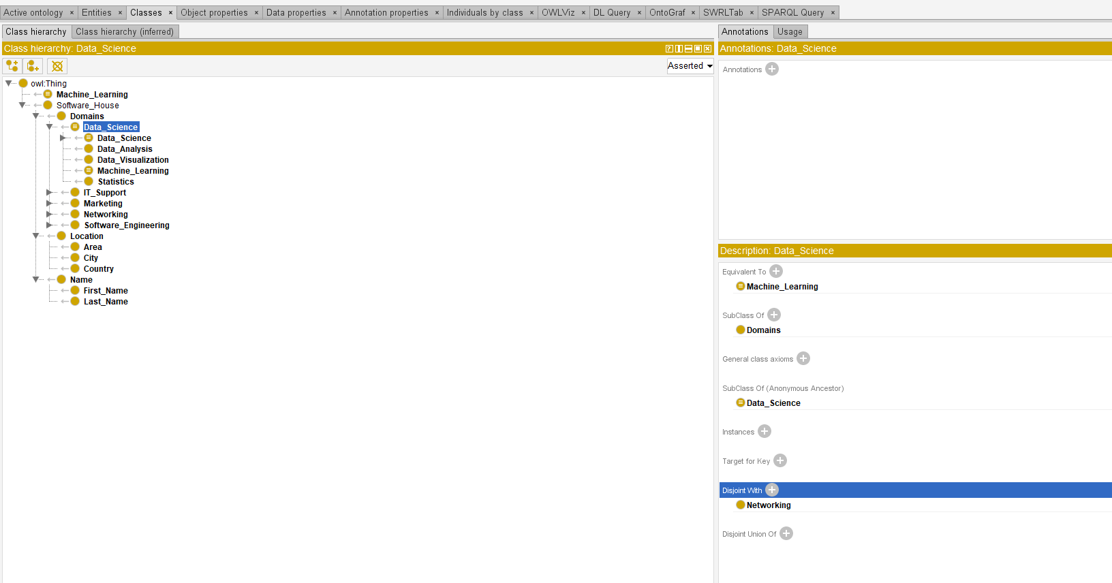

**Disjoint Object Properties:**

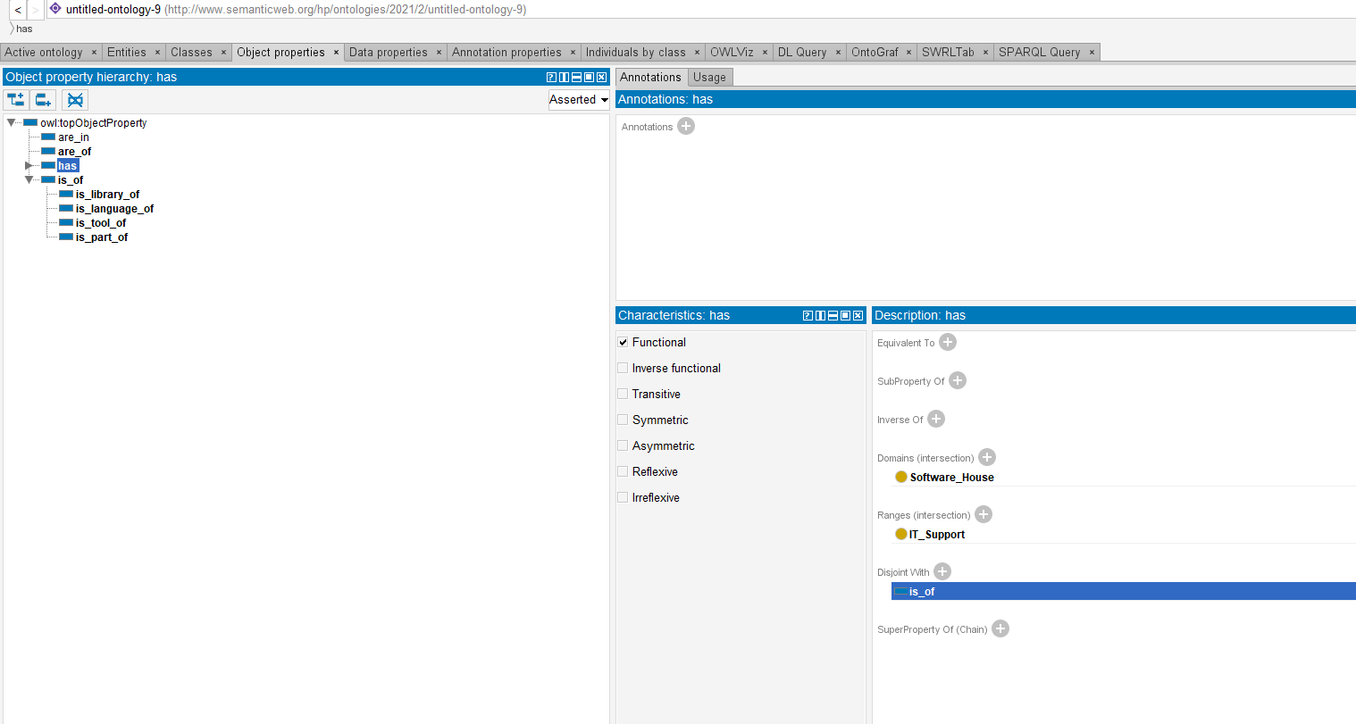

**Disjoint Data Properties:**

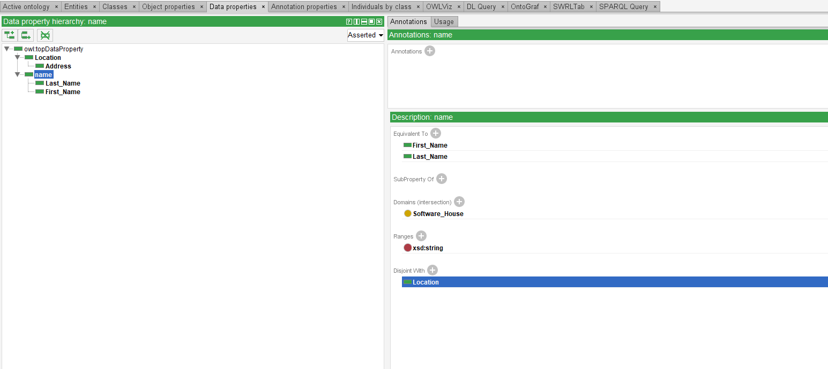

**Lab 08: Individuals**

**Adding Individuals Tab:**

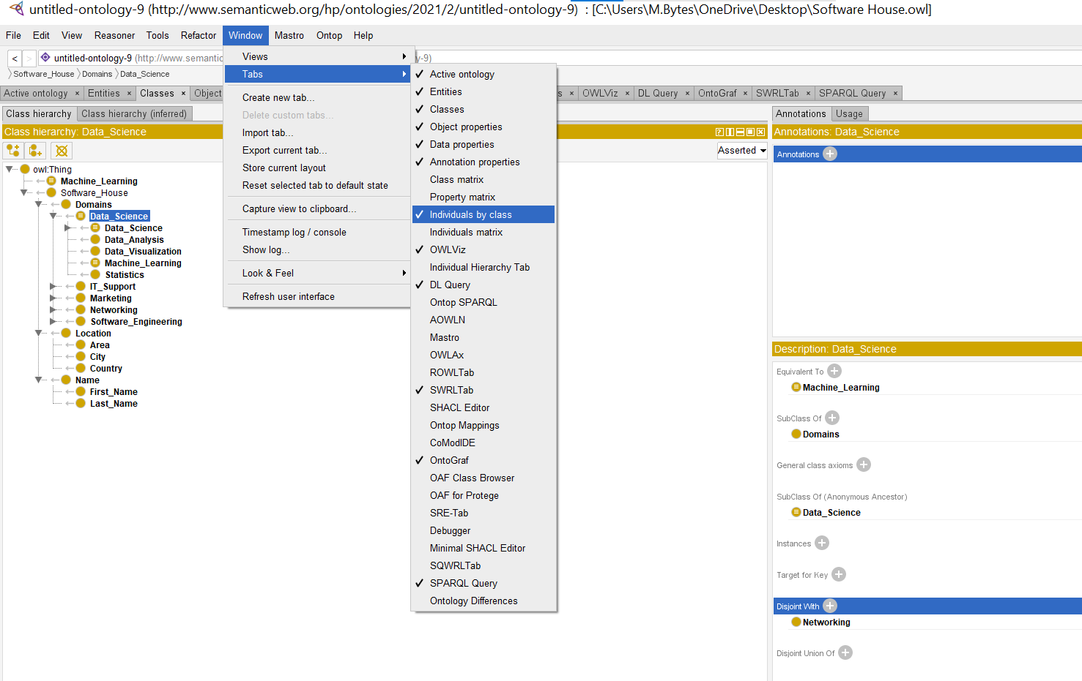

**Creating Individuals:**

**Individuals:**

**Lab 09: Object and data property assertion**

**Object Property Assertion:**

**Data Property Assertion:**

**Lab 10: Negative object and data property assertion**

**Negative Object Property Assertion:**

**Negative Data Property Assertion:**

**Lab 11: Inverse of**

**Inverse Of:**

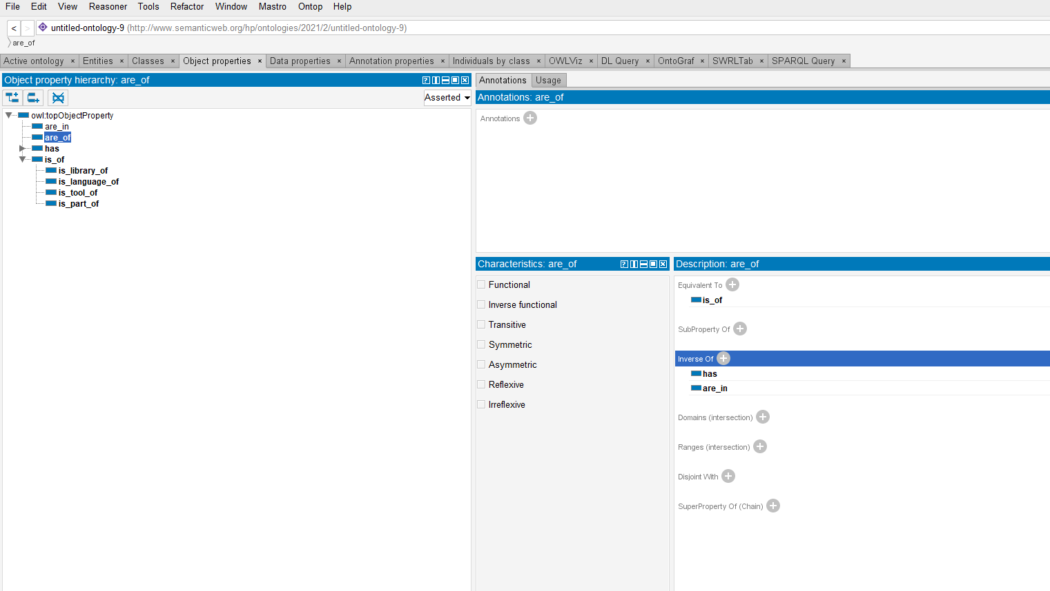



**Lab 12: Same individual as Different individual as**

**Same Individual as:**

**Different Individual as:**

**Lab 13: Cardinality**

**Setting Up Cardinality:**

**Cardinality:**

**Lab 14: Allvaluesfrom Somevaluesfrom Hasvalue**

**Lab 15: Fashion Ontology**

**Classes:**

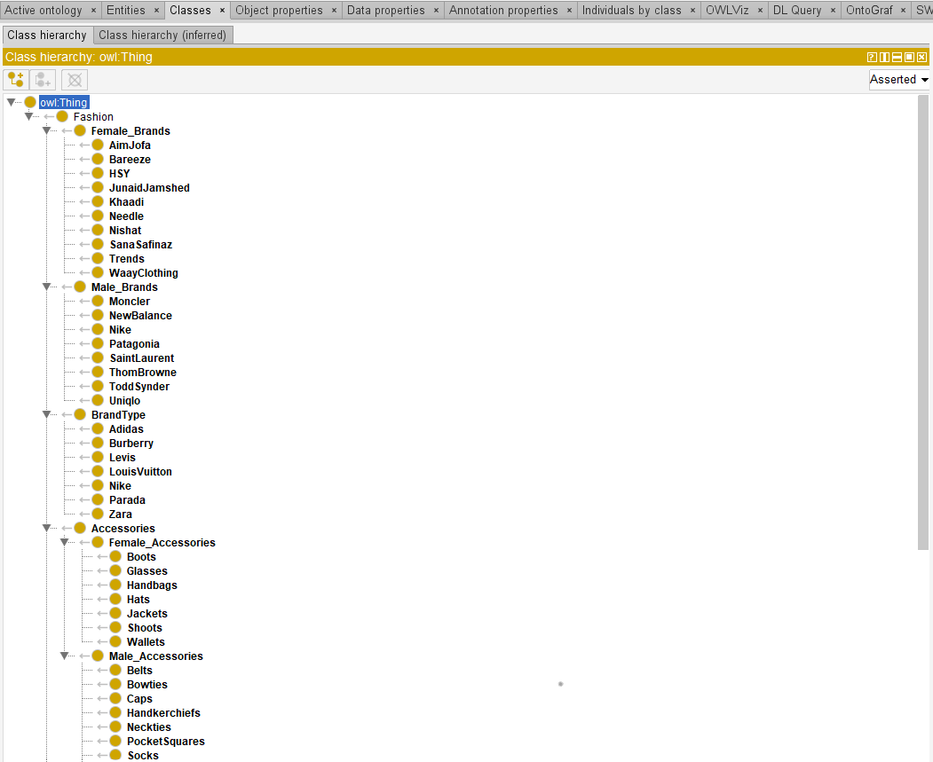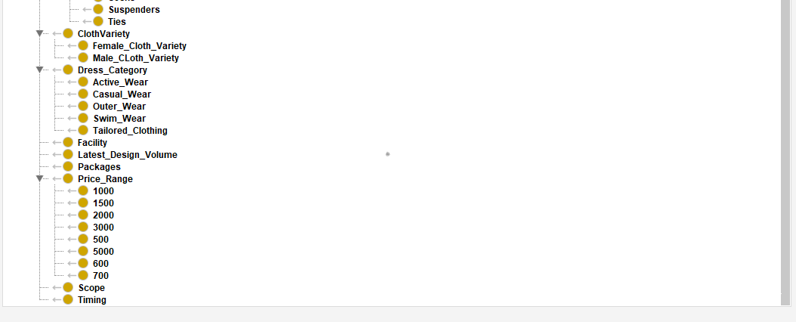

**Object Properties:**

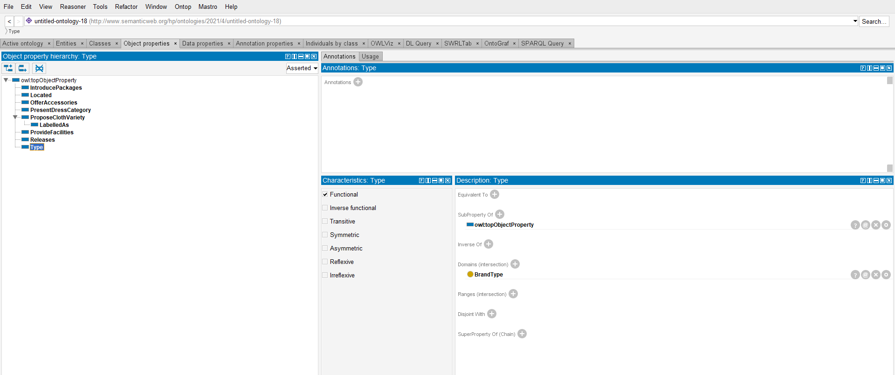

**Data Properties:**

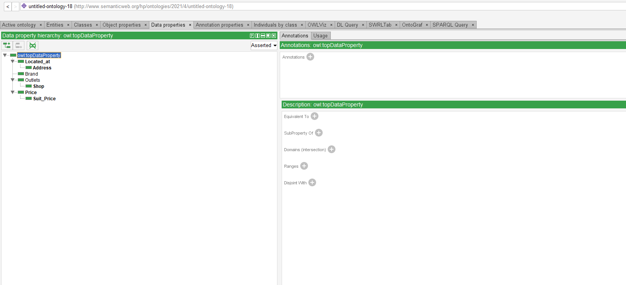

**Ontograf View:**

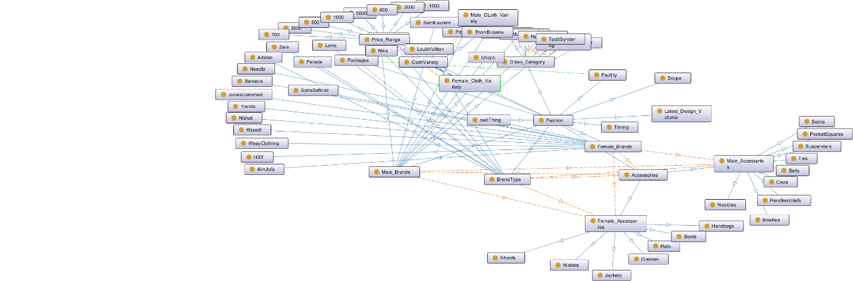

**OwlVIZ:**

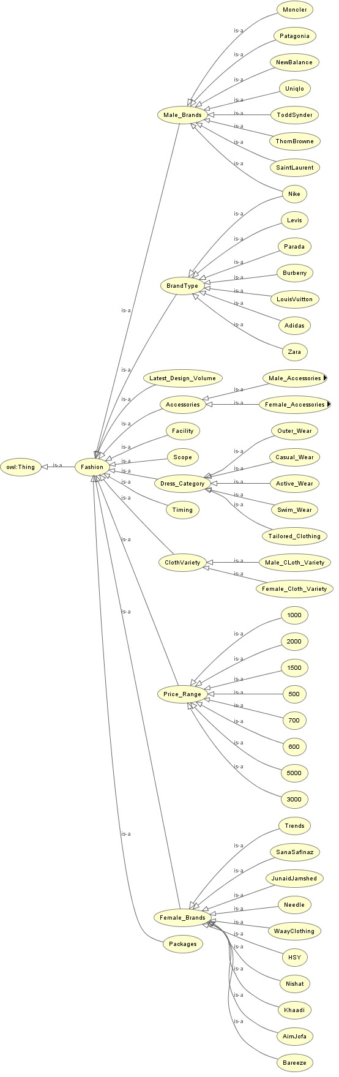

**Lab 16: Sports Ontology**

**Classes:**

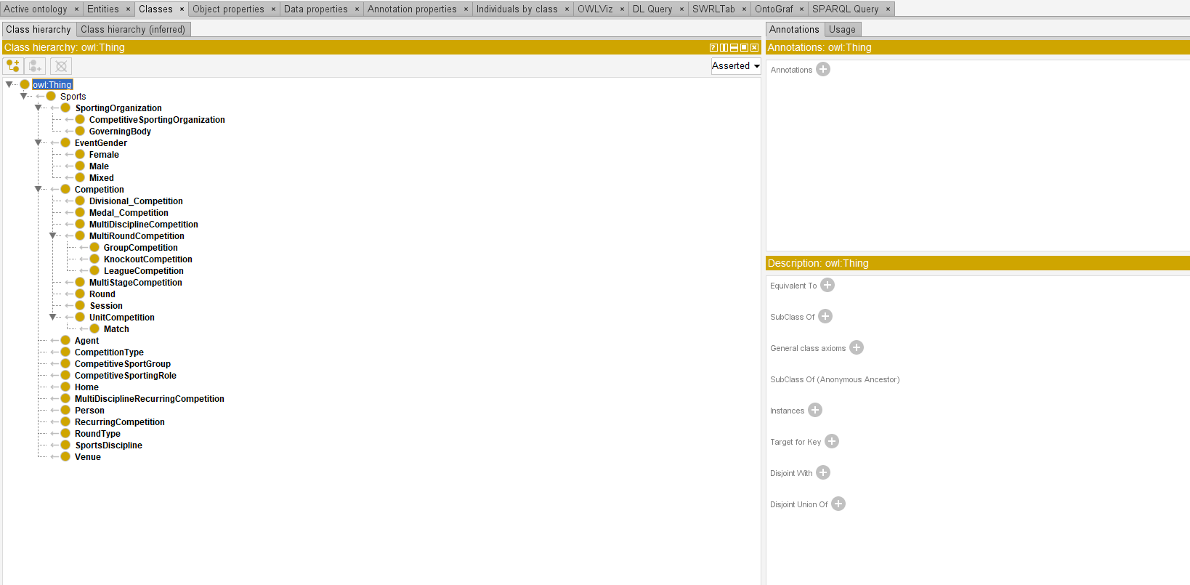

**Data Properties:**

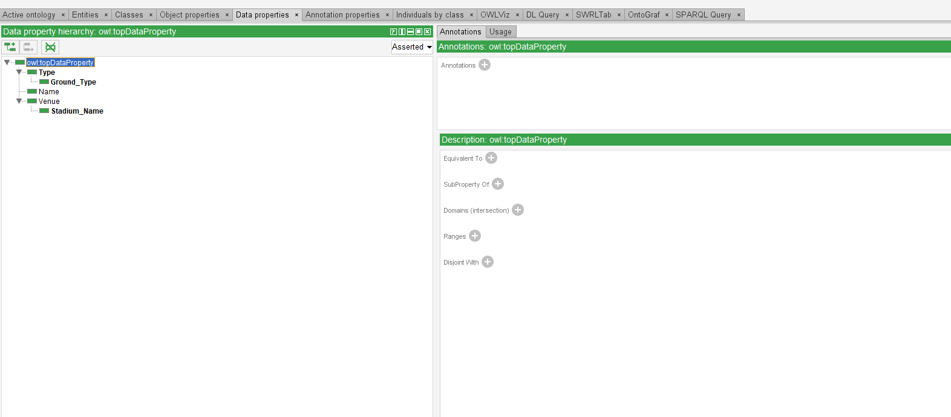

**Object Properties:**

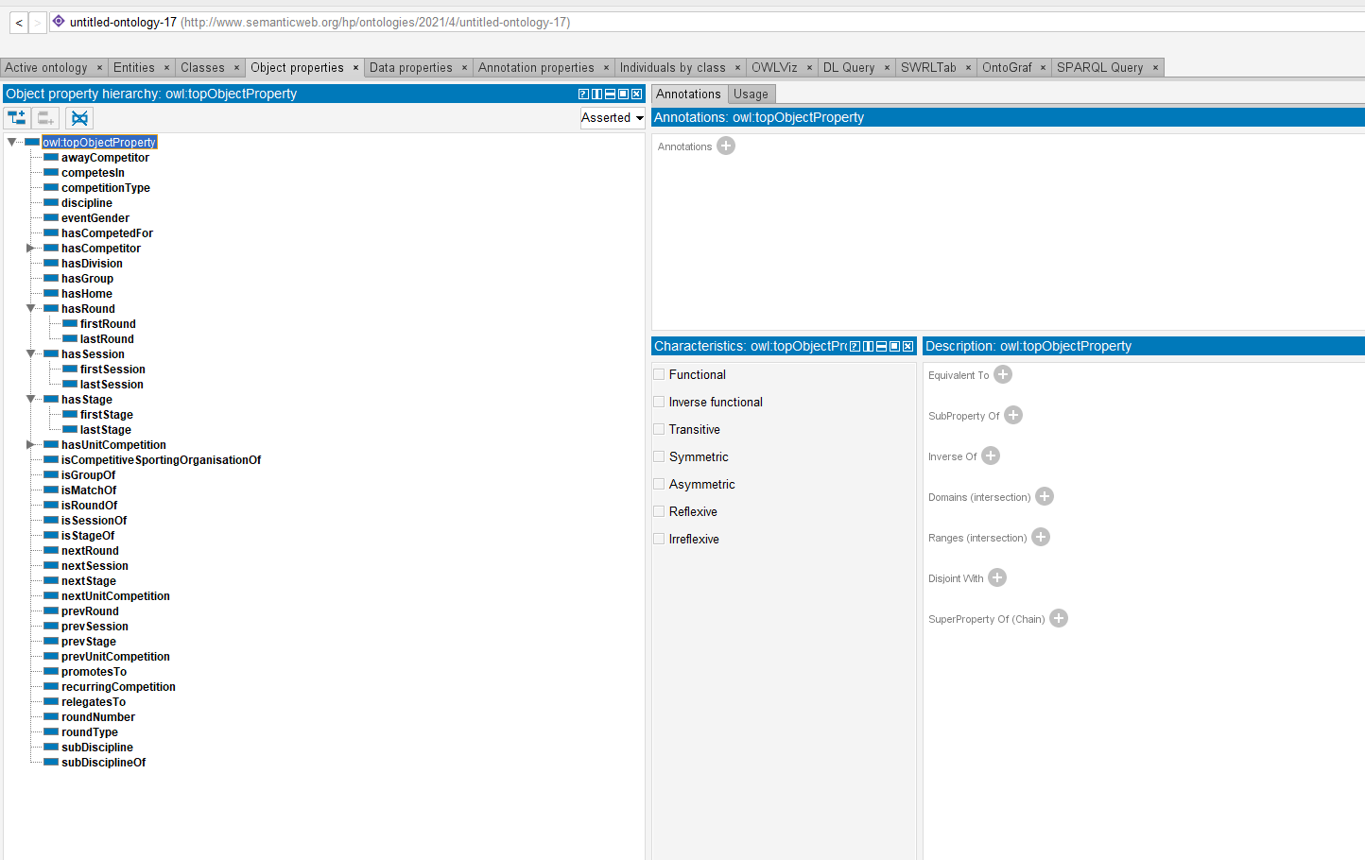

**Ontograf View:**

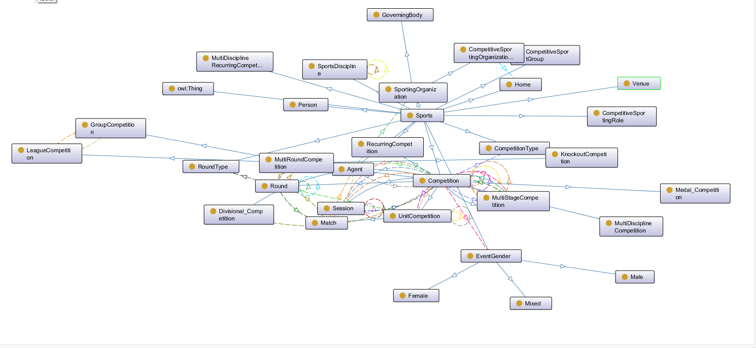

**OwlVIZ:**

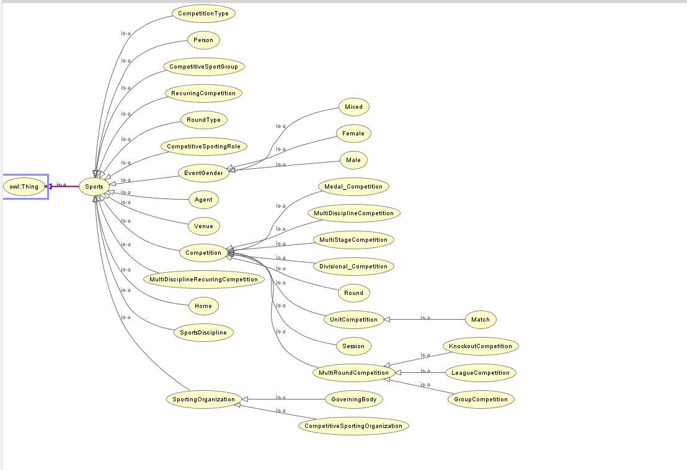

**Lab 17: Q/A system**

**Classes:**

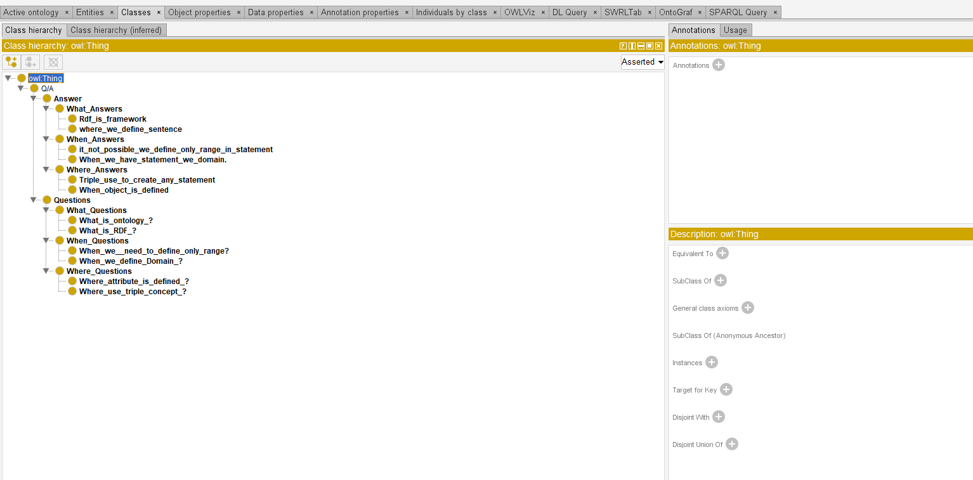

**Ontograf View:**

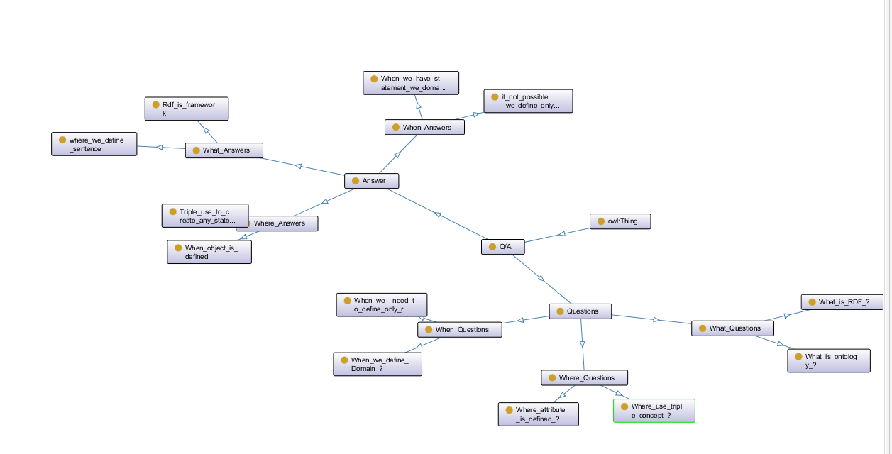

**OwlVIZ:**

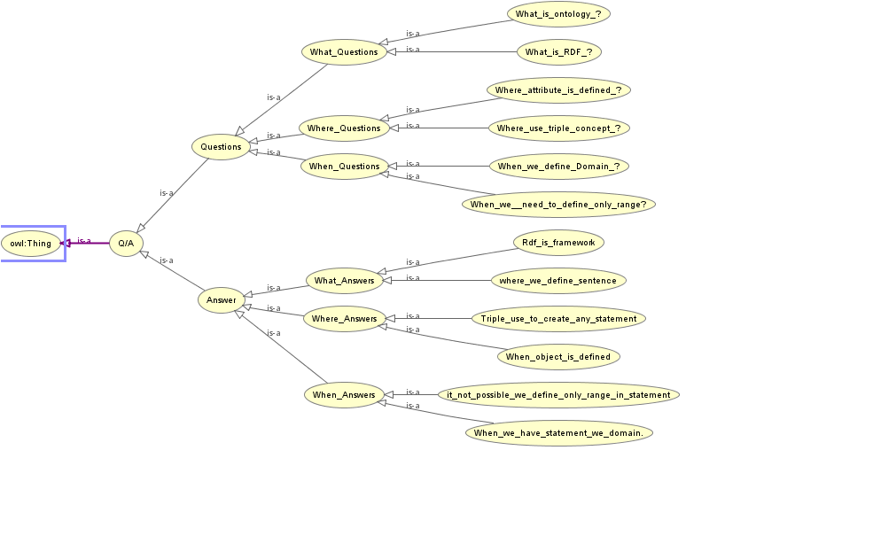

**Lab 18: family Ontology**

**Classes:**



**Data Properties:**

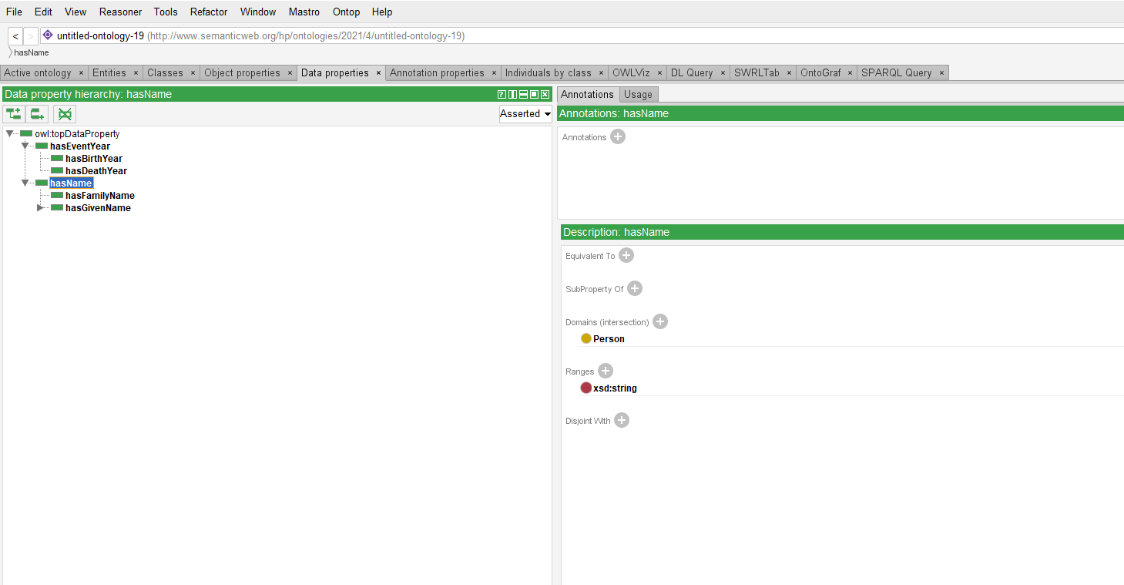

**Object Properties:**

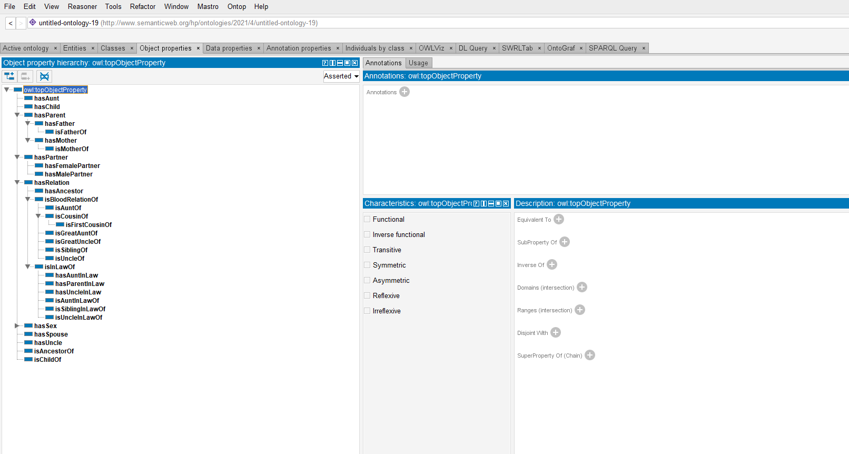

**Ontograf View:**

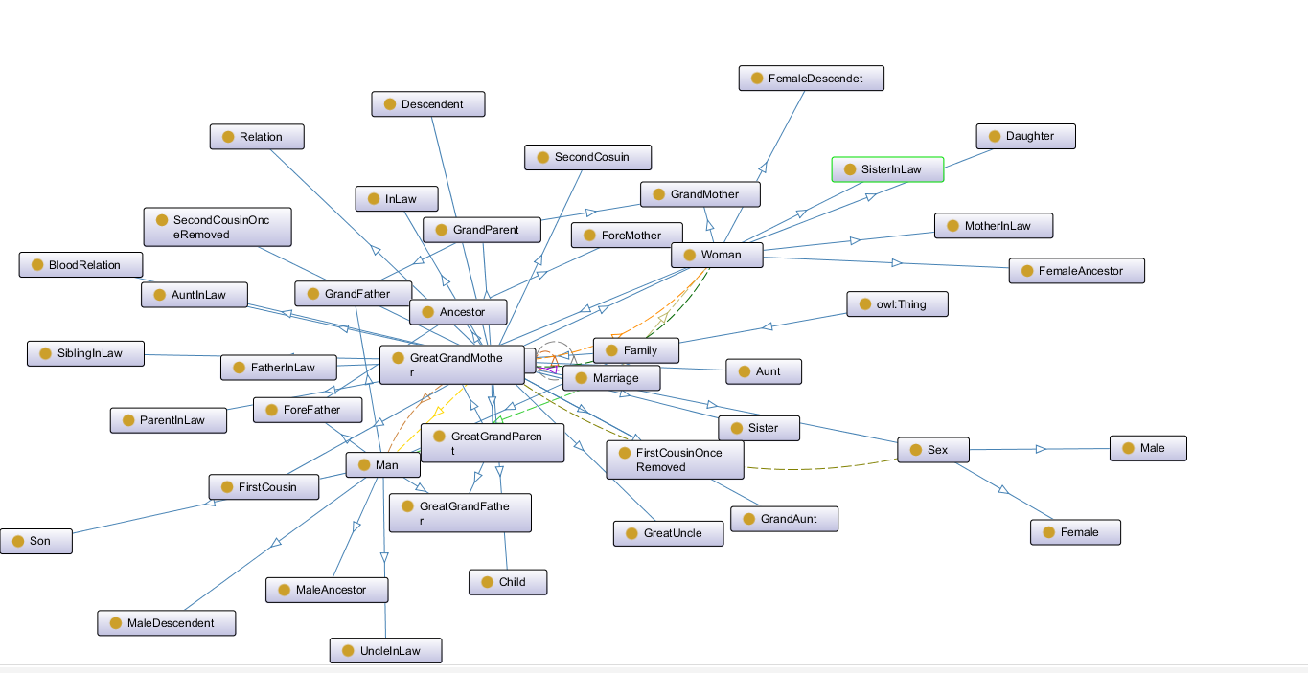

**OwlVIZ:**

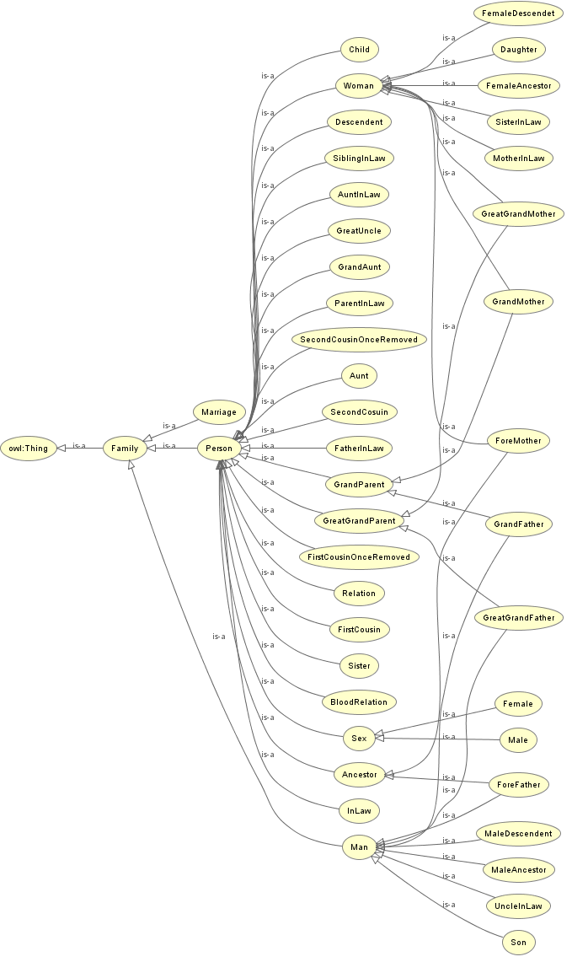

**Lab 19: Lab task date (5/5/21)**

**Lab 20: Lab task date (21/4/21)**

**Lab 21: assignment-01 (19/05/21)**

**Lab 22: assignment-01 (28/04/21)**

**QUIZ**

**PRESENTATION**